Predicting the Length of an LLM Answer from the Prompt
Final project report
Gal Mund (322544297) · Nadav Grossman (315111880) · 21 August 2026

Abstract
Answer length affects an LLM request’s cost, latency, and memory use, but is unknown before generation. We train two prompt-only classifiers on 300,000 WildChat examples. Locally trained DistilBERT (66M parameters, 256-token context) predicts four quartiles with 58.7% accuracy (25% chance); 91.2% of its predictions are within one bucket. Cloud-trained ModernBERT-large (395M parameters, 2,048-token context) predicts eight octiles with 43.4% accuracy (12.5% chance); 77.0% are within one bucket. In a simulated M/G/1 queue at 90% load, their priorities reduce average wait by 33% and 40%, capturing 60% and 72% of the oracle gain.

1. Introduction
An LLM’s output-token count affects a request’s cost, latency, and memory use, but is unknown until generation ends. We ask whether a text encoder can predict answer length from the prompt well enough to improve pricing, queueing, and memory reservation.
Exact token counts vary with sampling, style, and hidden system prompts, but a length range is enough for many serving decisions. DistilBERT predicts four equal-sized quartiles locally; ModernBERT-large predicts eight octiles in the cloud. We use these buckets as queue priorities. The goal is a useful length signal, not a direct comparison of the encoders.

2. Hypotheses
- H1. Answer length depends mainly on what the user asks. A text encoder should therefore beat chance on equal-sized buckets (25% for four classes and 12.5% for eight).
- H2. Prompt length is only a weak estimate of answer length, so both models should clearly outperform a rule based on prompt length.
- H3. Predicted length buckets should order a queue well enough to capture most of the gain from knowing the true lengths. More detailed ranks should capture more of that gain.

3. Related Work
Prior work predicts answer length by asking the LLM itself (Zheng et al., 2023), using a small encoder to predict buckets (S³; Jin et al., 2023; Arango et al., 2025), predicting token counts (SSJF; Qiu et al., 2024), or learning request order (Fu et al., 2024). TRAIL (Shahout et al., 2025) also uses buckets, but updates them after each generated token. We use prompt-only buckets because they are available before generation and map directly to queue priorities.

4. Data
We sample 300,000 English, single-turn conversations from WildChat-1M (Zhao et al., 2024). Their answers were generated by six snapshots from the GPT-3.5 Turbo and GPT-4 model families. Each example pairs the first user prompt with the cl100k_base token count of its answer. A fixed-seed 70/15/15 split gives 209,999 training, 45,000 validation, and 45,001 test examples.
Answers contain up to 4,096 tokens (median 416). For DistilBERT, training-set cutoffs at 229, 418, and 592 tokens define four equal-sized classes: Short, Medium, Long, and Very long. ModernBERT uses eight classes based on octiles from the same data. Prompt and answer length correlate at r = 0.34 on log counts and r = 0.10 on raw counts, making prompt length a weak signal.
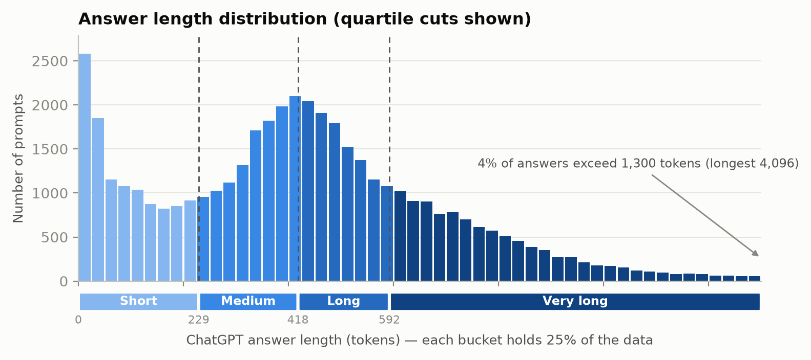
Figure 1. Test-set answer lengths. Dashed lines show DistilBERT’s quartile cutoffs; ModernBERT uses octiles from the same distribution.
Bucket | Tokens | Mean answer tokens | Example prompt | Example answer tokens
Short | 0–229 | 90 | Create image with Cursed Refaund | 18
Medium | 230–418 | 338 | how to make my music sound more 80s | 281
Long | 419–592 | 496 | Problems of integration of ICT in school | 497
Very long | 593+ | 867 | Type an essay on Singapore for me | 785
Table 1. Quartile buckets for the four-way task, with one real prompt from each bucket. The eight-way task divides the same range into octiles.

5. Method
Both classifiers use the same 209,999 prompts. DistilBERT-base-uncased (Sanh et al., 2019; 66M parameters, 256-token context) predicts four quartiles and trains locally on an Apple M4 Pro (batch 32). ModernBERT-large (Warner et al., 2024; 395M parameters, 2,048-token context) predicts eight octiles and trains in the cloud on an NVIDIA L40S in bfloat16 (batch 4). We also train a four-way ModernBERT head as a check and report it only as a side note.
Both models use cross-entropy loss and AdamW, with learning rates of 2×10⁻⁵ for DistilBERT and 3×10⁻⁵ for ModernBERT. They use 10% linear warmup and train for up to six epochs, with early stopping based on validation macro-F1.
The baselines are uniform random guessing (accuracy 1/k) and a rule that applies answer-length bucket cutoffs to prompt-token counts. We omit a majority-class baseline: equal-sized buckets make its accuracy equal to chance, while its within-one-bucket score would be misleadingly high because the most common class is in the middle. We report accuracy, macro-F1, and predictions within one bucket of the true class. Four-way and eight-way accuracies are not directly comparable because chance is 25% and 12.5%, respectively.

6. Results
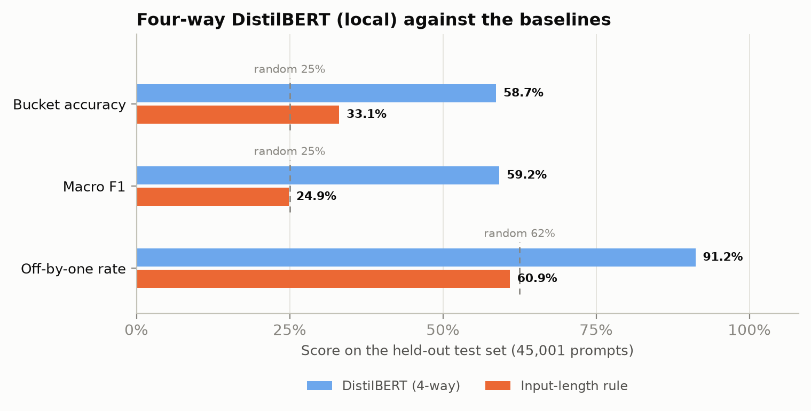
Figure 2. Four-way DistilBERT, trained locally, compared with the baselines. Dashed lines show uniform random guessing (25% accuracy and macro-F1; 62.5% within one bucket).
Method | Accuracy | Macro-F1 | Within one bucket
DistilBERT (4-way) | 58.7% | 59.2% | 91.2%
Input-length rule | 33.1% | 24.9% | 60.9%
Random guess | 25.0% | 25.0% | 62.5%
Table 2. Four-way DistilBERT results on the 45,001-prompt test set. The model was trained locally; chance accuracy is 25%.
DistilBERT reaches 58.7% accuracy and 59.2% macro-F1 across four quartiles. This is well above random guessing (25%) and the prompt-length rule (33.1%). Most errors are close: 91.2% of predictions are within one bucket of the true class.
On the same test set, eight-way ModernBERT-large reaches 43.4% accuracy and 43.9% macro-F1, versus 12.5% chance (Table 3). It is within one bucket 77.0% of the time, versus 34.4% for random guessing. The prompt-length rule reaches 18.4% accuracy. Both encoders beat chance and the prompt-length rule, supporting H1 and H2. Four-way and eight-way accuracies are not directly comparable.
Method | Accuracy | Macro-F1 | Within one bucket
ModernBERT-large (8-way) | 43.4% | 43.9% | 77.0%
Input-length rule | 18.4% | 13.6% | 39.9%
Random guess | 12.5% | 12.5% | 34.4%
Table 3. Eight-way ModernBERT-large results on the same test set. The model was trained in the cloud; chance accuracy is 12.5%. These accuracies are not directly comparable with Table 2.
Side note. Four-way ModernBERT reaches 60.3% accuracy and is within one bucket 93.3% of the time, close to DistilBERT’s 58.7%. Our main result uses its more detailed eight-way ranks, not this small gain on four buckets.
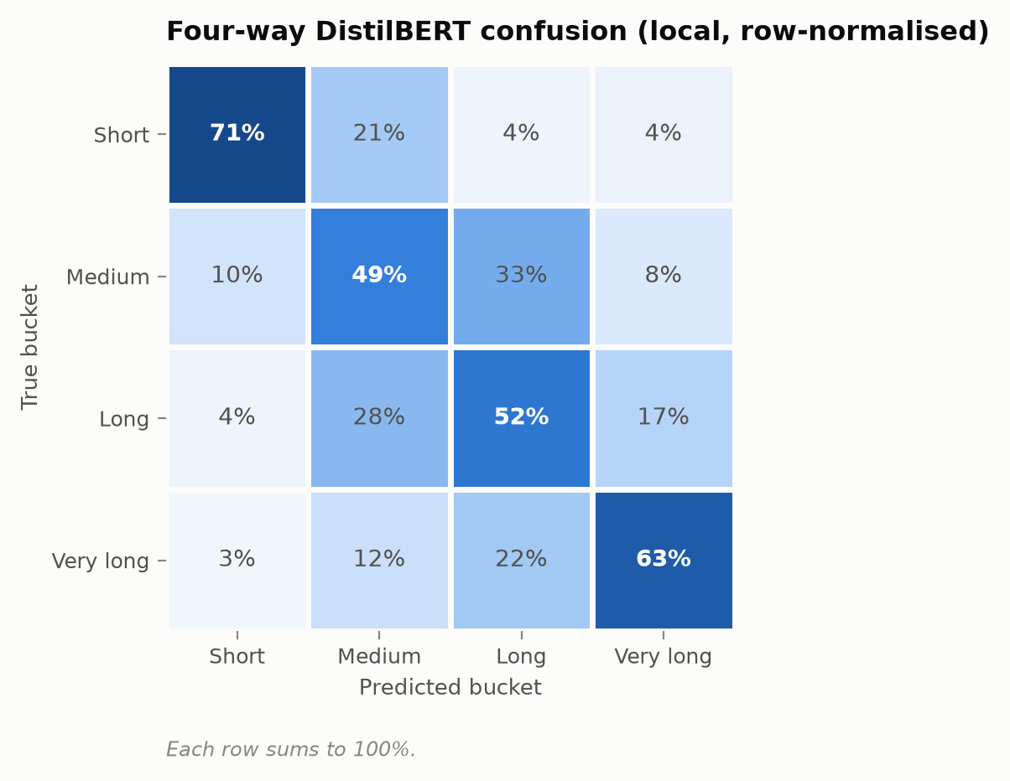
Figure 3. Four-way DistilBERT confusion matrix, normalised by row.
The extreme classes are easiest in the four-way task: 71% accuracy for Short and 63% for Very long. The middle classes reach 49% and 52%. Short is mistaken for Very long about 4% of the time; the reverse occurs about 3% of the time.

7. Application — Scheduling a Queue
Shortest-job-first minimises average waiting time when job sizes are known. For LLM serving, a predicted length bucket can serve as a priority before generation begins: four priority levels for DistilBERT and eight for ModernBERT.
We model an M/G/1 queue with Poisson arrivals and one non-preemptive server. Service time is 0.5 s plus 1 s per 50 output tokens, using resampled test prompts (E[S] = 9.45 s). The arrival rate sets a target utilisation of ρ = λ E[S]. After completing a request, the server selects the highest-priority request currently waiting; ties use first-come, first-served (FCFS) order. Each policy receives the same arrivals but orders them by FCFS, shortest prompt, four-way DistilBERT, eight-way ModernBERT-large, or true service time (the oracle). We average 10 runs of 200,000 requests, discard the first 20,000 as warm-up, and do not run an LLM.
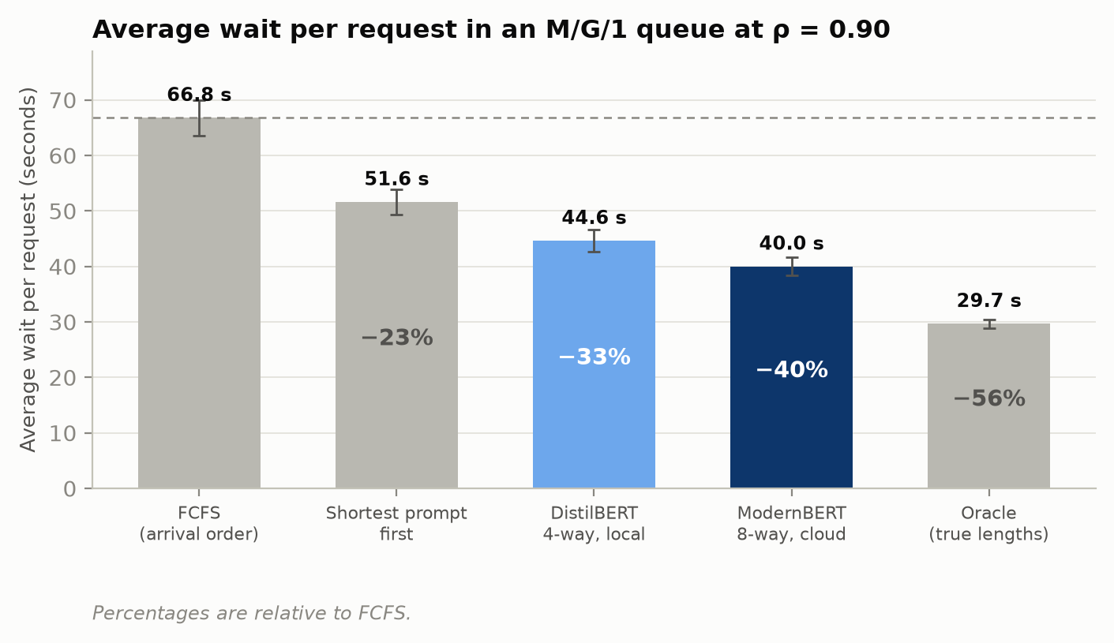
Figure 4. Average wait per request for each policy at ρ = 0.90. Error bars show one standard deviation across runs.
Queue order | Avg wait | vs FCFS | Share of oracle gain
FCFS (arrival order) | 66.8 s | — | 0%
Shortest prompt first | 51.6 s | −23% | 41%
DistilBERT, 4 priorities | 44.6 s | −33% | 60%
ModernBERT-large, 8 priorities | 40.0 s | −40% | 72%
Oracle (true lengths) | 29.7 s | −56% | 100%
Table 4. Average wait for each policy at ρ = 0.90. The Pollaczek–Khinchine formula gives 65.1 s for FCFS. Cobham’s formula gives 43.6 s for DistilBERT’s four priorities and 39.1 s for ModernBERT’s eight.
DistilBERT’s four priorities reduce average wait from 66.8 s to 44.6 s (33%) and capture 60% of the oracle gain, supporting H3. Eight-way ModernBERT lowers it to 40.0 s (40%, or 72% of the oracle gain), despite the harder classification task (43.4% accuracy versus 12.5% chance). Unlike accuracy, waiting time is comparable across systems. The finer ranks improve ordering enough to outweigh additional classification errors.
Side note. At this load, a four-way ModernBERT head produces a 43.2 s average wait, almost the same as DistilBERT. The eight-way head gains more because it provides finer priorities, not because it uses a different encoder.

ρ | FCFS (sim / P–K) | DistilBERT 4-way (sim / Cobham) | ModernBERT-large 8-way (sim / Cobham) | 4-way oracle share | 8-way oracle share
0.50 | 7.2 / 7.2 s | 6.2 / 6.2 s | 6.0 / 6.0 s | 67% | 77%
0.70 | 16.9 / 16.9 s | 13.1 / 13.0 s | 12.5 / 12.4 s | 66% | 76%
0.85 | 41.0 / 41.0 s | 28.6 / 28.6 s | 26.2 / 26.3 s | 62% | 74%
0.90 | 66.8 / 65.1 s | 44.6 / 43.6 s | 40.0 / 39.1 s | 60% | 72%
0.95 | 133.5 / 137.4 s | 85.1 / 87.5 s | 74.0 / 76.0 s | 56% | 69%
Table 5. Simulation and closed-form results across server loads. Predicted priorities help more at higher utilisation because a longer queue gives each policy more requests to choose from.
DistilBERT’s reduction over FCFS grows from 15% at ρ = 0.50 to 36% at ρ = 0.95; ModernBERT-large’s grows from 17% to 45%. Errors between neighbouring buckets have little effect on queue order. Scheduling changes waiting time, not the number of decoded tokens. Kleinrock's conservation law fixes the service-load-weighted mean across classes, even though the mean across requests can fall. Shorter predicted classes therefore benefit at the expense of longer predicted classes. At ρ = 0.90, requests predicted as Short wait 7.0 s, while those predicted as Very long wait 150 s (22×). The 95th-percentile wait rises from 217 s under FCFS to 238 s. With eight priorities, the longest predicted octile waits 222 s versus 6.7 s for the shortest (33×), but the 95th percentile falls to 176 s because fewer requests enter the lowest-priority class.

7.1 Comparison with Prior Work
System | Buckets | Exact bucket | Within one bucket | Serving result
DistilBERT (ours) | 4 | 58.7% (2.35× chance) | 91.2% | −33% wait
ModernBERT-large (ours) | 8 | 43.4% (3.47× chance) | 77.0% | −40% wait
Vicuna self-prediction (rough) | 4 / 8 | ≈51–60% / ≈30–37% | ≈88–94% / ≈63–74% | +86% throughput
Arango et al. (with Shahout) | 20 | 24.0% (4.8× chance) | Not reported | True lengths only: −14.31% latency at 64 RPS; −28.89% at 128 RPS
TRAIL (Shahout et al.) | 10 | Not reported | Not reported | −40% to −50% latency
Table 6. Bucket prediction and serving results. Vicuna scores are rough simulations using 1.0–1.5 tokens per word; Arango et al.’s serving test used true lengths; TRAIL’s percentages are converted from its reported ratios. Serving measures differ, so compare direction rather than rank.
Arango et al.’s 20-bucket predictor has lower exact accuracy than ours (24.0%), but it solves a finer task and reaches 4.8× chance. Our models reach 2.35× and 3.47× chance. Together, these results support the same conclusion: prompts contain a useful length signal. DistilBERT overlaps Vicuna’s rough four-bucket range, while ModernBERT is above its rough eight-bucket range under the stated assumptions. Our models cut queue wait by 33–40%; TRAIL reports about 40–50% lower latency in a different serving setup.

8. Limitations
- The predictors cover only English, single-turn WildChat prompts. Their answers come from six GPT-3.5 Turbo and GPT-4 snapshots rather than one fixed model.
- WildChat does not provide consistent system prompts or decoding settings. Also, 10,296 test rows repeat prompt text found in the training set, so the reported accuracy may be too high.
- The simulation assumes Poisson arrivals, one server, no batching or preemption, and a linear relation between answer length and service time.
- Strict priorities can starve long requests. Adding fairness would reduce this problem but also give up some of the waiting-time gain.

9. Future Work
Test both predictors on a real serving system and apply them to KV-cache reservation, batch packing, routing, and price estimates. Future evaluations should include other LLMs, multi-turn and non-English requests, code and tool use, and transfer between answering models. Releasing the pipeline, models, labels, seeds, and splits would support reproduction.

10. Conclusion
Two prompt-only classifiers predict answer-length buckets on WildChat. DistilBERT reaches 58.7% quartile accuracy (25% chance), with 91.2% of predictions within one bucket. Its four queue priorities reduce average wait by 33%, capturing 60% of the oracle gain. ModernBERT-large reaches 43.4% octile accuracy (12.5% chance), with 77.0% within one bucket. Its eight priorities reduce wait by 40%, capturing 72% of the oracle gain. Prompt-based buckets are useful when ordering matters more than exact length, and finer ranks help more.

References
Arango, I., Noori, A., Huang, Y., Shahout, R., & Yu, M. (2025). Prefix and output length-aware scheduling for efficient online LLM inference. SLLM 2025.
Fu, Y., Zhu, S., Su, R., Qiao, A., Stoica, I., & Zhang, H. (2024). Efficient LLM scheduling by learning to rank. NeurIPS 2024. arXiv:2408.15792.
Jin, Y., Wu, C.-F., Brooks, D., & Wei, G.-Y. (2023). S³: Increasing GPU utilization during generative inference for higher throughput. NeurIPS 2023. arXiv:2306.06000.
Qiu, H., Mao, W., Patke, A., Cui, S., Jha, S., Wang, C., Franke, H., Kalbarczyk, Z., Başar, T., & Iyer, R. K. (2024). Efficient interactive LLM serving with proxy model-based sequence length prediction (SSJF). arXiv:2404.08509.
Sanh, V., Debut, L., Chaumond, J., & Wolf, T. (2019). DistilBERT, a distilled version of BERT: smaller, faster, cheaper and lighter. arXiv:1910.01108.
Shahout, R., Malach, E., Liu, C., Jiang, W., Yu, M., & Mitzenmacher, M. (2025). Don’t stop me now: Embedding based scheduling for LLMs. ICLR 2025. arXiv:2410.01035.
Warner, B., Chaffin, A., Clavié, B., Weller, O., Hallström, O., Taghadouini, S., Gallagher, A., Biswas, R., Ladhak, F., Aarsen, T., Cooper, N., Adams, G., Howard, J., & Poli, I. (2024). Smarter, better, faster, longer: A modern bidirectional encoder for fast, memory efficient, and long context fine-tuning and inference. arXiv:2412.13663.
Zhao, W., Ren, X., Hessel, J., Cardie, C., Choi, Y., & Deng, Y. (2024). WildChat: 1M ChatGPT interaction logs in the wild. ICLR 2024. arXiv:2405.01470.
Zheng, Z., Ren, X., Xue, F., Luo, Y., Jiang, X., & You, Y. (2023). Response length perception and sequence scheduling: An LLM-empowered LLM inference pipeline. NeurIPS 2023. arXiv:2305.13144.

